SMART PARKING

* Parking slots have become a widespread problem in urban development. In this context,
* the growth of vehicles inside the university’s campus is rapidly outpacing the available
* parking spotsforstudentsand staff as well. Thisissue can bemitigated by the introduction
* of parking management for the smartcampus which targets to assist individually match
* drivers to vacant parking slots, saving time, enhance parking space utilization, decrease
* management costs, and alleviate traffic congestion. This paper develops an IoT
* Raspberry Pi-based parking management system (IoT-PiPMS) to help staff/studentsto
* easily find available parking spots with real-time vision and GPS 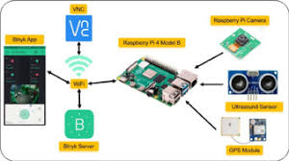coordinates, all by
* means of a smartphone application. Our system composes of Raspberry Pi 4 B+ (RPi)
* embedded computer, Pi camera module, GPS sensor, and ultrasonic sensors. In the IoT-
* PiPMS, RPi 4 B+ is used to gather and process data input from the sensors/camera, and
* the data is uploaded via Wi-Fi to the Blynk IoTserver. Ultrasonic sensors and LEDs are
* exploited to detect the occupancy of the parking spots withthe support of the Pi camera
* to ensure data accuracy. Besides, the GPS module is installed in the system to guide
* drivers to locate parking areas through the Blynk App. that discovers parking spaces
* availability over the Internet. The system prototype is fabricated and tested practically
* to prove its functionality and applicability. According to the results, the IoT-PiPMS can
* effectively monitor the occupancy of outdoor parking spaces in the smart campus
* environment, and its potency in terms of updating the data to the IoT server in real-time

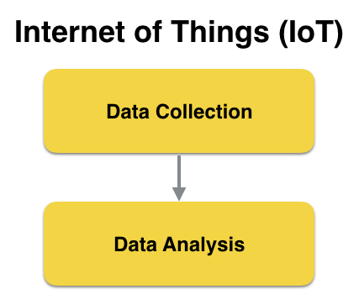

* I can provide a textual overview of the project's components and benefits, but I cannot generate diagrams, schematics, or screenshots in this text-based format. Here's a description of the project:

1. \*\*Project Objectives:\*\*
2. The project aims to create a real-time parking availability system that benefits drivers by providing up-to-the-minute information about available parking spots in a designated area. This system should alleviate common parking issues like circling for parking spots, reducing traffic congestion, and saving time.
3. \*\*IoT Sensor Setup:\*\*

* 1. \*\*Ultrasonic Sensors:\*\* Ultrasonic sensors are placed at each parking spot to detect the presence of a vehicle. These sensors transmit data to a central hub.
* 2. \*\*Central Hub:\*\* A central Raspberry Pi-based hub collects data from the ultrasonic sensors, processes it, and communicates with the mobile app.
* \*\*Mobile App Development:\*\*
* The mobile app is designed for both Android and iOS platforms. It provides drivers with real-time information on parking spot availability and allows them to:
* - View a map showing available parking spots.
* - Reserve a parking spot in advance.
* - Receive notifications when their reserved spot is about to expire.
* - Pay for parking through the app.
* \*\*Raspberry Pi Integration:\*\*
* The Raspberry Pi acts as the brain of the system. It receives data from sensors, processes it, and communicates with the mobile app. It is responsible for:
* - Data aggregation from the sensors.
* - Managing reservations and payments.
* - Sending real-time updates to the mobile app.
* - Ensuring the security and integrity of the system.

\*\*Code Implementation:\*\*

* The code is divided into two main components:
* 1. \*\*Sensor Code:\*\* The code on each Raspberry Pi sensor node reads the ultrasonic sensor data and sends it to the central hub. It also handles sensor calibration and error checking.
* 2. \*\*Central Hub Code:\*\* This code manages data reception, aggregation, and communication with the mobile app. It includes logic for parking spot availability, reservation management, and payment processing.

\*\*Benefits:\*\*

* - \*\*Reduced Congestion:\*\* Drivers can quickly find available parking spots, reducing the time spent searching for parking, which in turn reduces traffic congestion.
* - \*\*Time Savings:\*\* The system saves drivers time by providing real-time parking information, helping them reach their destinations faster.
* - \*\*Environmental Benefits:\*\* Less time spent circling for parking means reduced fuel consumption and lower emissions.
* - \*\*Convenience:\*\* Drivers can reserve and pay for parking in advance, making the parking experience more convenient.
* - \*\*Revenue Generation:\*\* The system can also generate revenue through parking fees and provide valuable data for city planning.
* While I can't provide actual diagrams or screenshots, you can create these visuals using various design and diagramming tools to further illustrate the project's architecture and user interface.

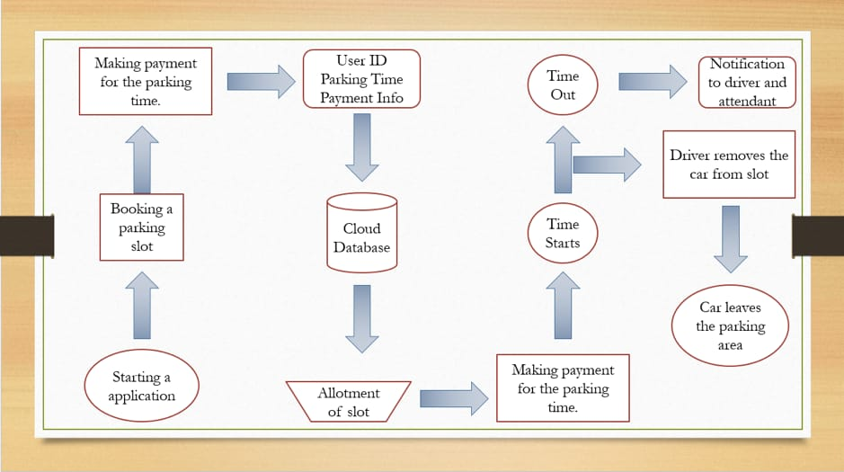

* Living in cities can be difficult. Urbanization is on the rise, and congestion in the city is becoming increasingly complex every day. It creates the need to launch an automated system that allows users to book their parking slot with just a few clicks on a mobile app. Now, the problem is quite apparent. But the big question is, what can technology do to solve it? Is there a way out? Smart Parking System means an IoT-based system that sends data about free and residential parking areas via a web/mobile app.
* Smart car parking systems using IoT, which include sensors and microcontrollers, can be available in each parking slot. The user will then be able to track the availability of all parking spaces and can choose the best one. Alternatively, the user can also view the duration of the parking usage from the application, and costs can be calculated and sent to the user with the help of smart parking meters. Not only this, but the user can also decide to extend their time. All that is needed is a working internet connection.
* Logo
* User
* Home > Business Blogs > IoT > IoT-based Smart Parking System – A Step Towards Building Smart City
* Search …
* IoT-based Smart Parking System – A Step Towards Building Smart City
* Smart Parking Systems using IoT
* May 28, 202227,910
* Share
* Cloud-based Smart Parking System based on IoT
* Living in cities can be difficult. Urbanization is on the rise, and congestion in the city is becoming increasingly complex every day. It creates the need to launch an automated system that allows users to book their parking slot with just a few clicks on a mobile app. Now, the problem is quite apparent. But the big question is, what can technology do to solve it? Is there a way out? Smart Parking System means an IoT-based system that sends data about free and residential parking areas via a web/mobile app.
* Smart car parking systems using IoT, which include sensors and microcontrollers, can be available in each parking slot. The user will then be able to track the availability of all parking spaces and can choose the best one. Alternatively, the user can also view the duration of the parking usage from the application, and costs can be calculated and sent to the user with the help of smart parking meters. Not only this, but the user can also decide to extend their time. All that is needed is a working internet connection.
* Parking in cities: A Perennial Problem
* One of the most critical problems in urban cities is car parking and traffic control systems. Finding parking space is often difficult for drivers in modern cities, thanks to the growing number of private car users.
* City planners can see this situation as an opportunity for IoT-based smart parking in a busy city environment to ramp up the efficiency of their parking facilities and lead to reduced search times, traffic congestion, and road accidents.
* For instance, if drivers are notified about the availability of parking spaces for their intended destination and surrounding areas, parking issues and traffic congestion can be solved using smart parking using IoT technology.
* Following the rapid development of sensory technology, many modern cities have chosen to deploy various IoT-based systems for monitoring purposes. For example, some parking programs claim that citizens get real-time information about available parking spaces with IoT smart parking systems.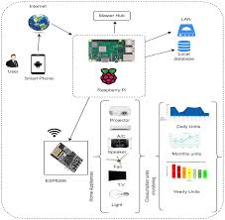
* Such systems require efficient sensors installed in parking lots to accommodate residential and data processing units to quickly obtain real-time data from various sources.
* Cloud-based Smart Parking System based on IoT
* Living in cities can be difficult. Urbanization is on the rise, and congestion in the city is becoming increasingly complex every day. It creates the need to launch an automated system that allows users to book their parking slot with just a few clicks on a mobile app. Now, the problem is quite apparent. But the big question is, what can technology do to solve it? Is there a way out? Smart Parking System means an IoT-based system that sends data about free and residential parking areas via a web/mobile app.
* Smart car parking systems using IoT, which include sensors and microcontrollers, can be available in each parking slot. The user will then be able to track the availability of all parking spaces and can choose the best one. Alternatively, the user can also view the duration of the parking usage from the application, and costs can be calculated and sent to the user with the help of smart parking meters. Not only this, but the user can also decide to extend their time. All that is needed is a working internet connection.
* Parking in cities: A Perennial Problem
* One of the most critical problems in urban cities is car parking and traffic control systems. Finding parking space is often difficult for drivers in modern cities, thanks to the growing number of private car users.
* City planners can see this situation as an opportunity for IoT-based smart parking in a busy city environment to ramp up the efficiency of their parking facilities and lead to reduced search times, traffic congestion, and road accidents.
* For instance, if drivers are notified about the availability of parking spaces for their intended destination and surrounding areas, parking issues and traffic congestion can be solved using smart parking using IoT technology.
* Following the rapid development of sensory technology, many modern cities have chosen to deploy various IoT-based systems for monitoring purposes. For example, some parking programs claim that citizens get real-time information about available parking spaces with IoT smart parking systems.
* Such systems require efficient sensors installed in parking lots to accommodate residential and data processing units to quickly obtain real-time data from various sources.
* [31/10, 9:50 am] Thirisha Clg: Some major daily parking issues include:
* Lack of parking spaces, mainly in the urban area
* Misuse of available parking spaces
* More time and fuel/gas are used to find open parking spaces
* Difficulty in finding vehicles at large parking lots
* Traffic congestion is concentrated on underutilized parking spaces
* Business parking lots are taken over by passenger parking
* Incorrect parking
* Proper management of disabled areas & unused private parking lots
* The natural impact of excessive fuel consumption in search of a parking space
* Unclear parking policies.
* All these issues are a regular part of the parking experience in cities and towns across India. But that need not be the same way. Smart Parking System can solve the issue.